Author

College name

Part 5

Table of Contents

Overview 2

Technologies 2

Description 2

Screenshots 2

Project Structure 4

Code 5

JSP 5

Servlets 9

XMLS 26

Report

# Overview

The objective of the Project Maintenance Application to help users to add, update, delete and view all the products. This application undergoes 6 development stages. Following is the description of each stage –

1. Part 1 - Creation of skeletal structure of the application.
2. Part 2 - Adding Custom tags for validation.
3. Part 3 - Application development using JDBC.
4. Part 4 - Application development using EclipseLink JPA.
5. Part 5 – Introduction of SSL and Authentication.
6. Part 6 – Integration with existing Music Store Website

# Technologies

Java 1.7, Servlets, JSP, JDBC, JPA (EclipseLink), MySQL, SSL Authentication

# Description

Part 5 of Product Maintenance Application introduces the entry level operation such as Add, Update, Delete and View. All the functionalities are achieved by reading the data from database tables using JPA Specification. All the urls for this application are secured by SSL Authentication.

# Screenshots

1. Welcome Page – This is the landing page when we start the project.

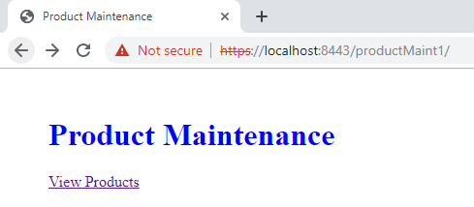

1. Login – User has to login to enter the system.

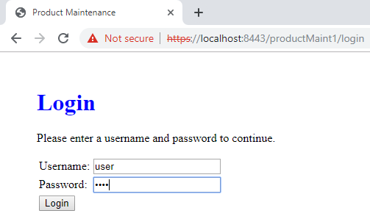

1. Display Products – After Clicking “View Products”, it will fetch all the products from database and display here.

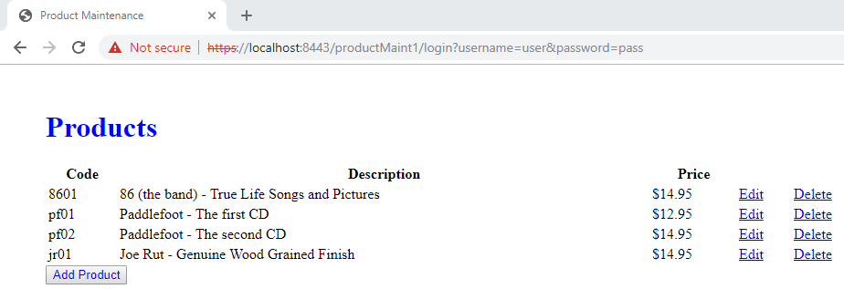

1. Add Product - After Clicking “Add Product”, it will display add product page where you can enter the details and add them to database.

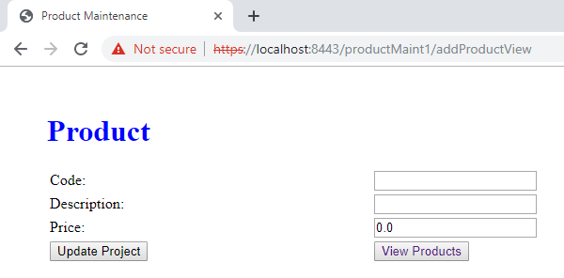

1. Update Product - After Clicking “Edit”, it will redirect to update product page with corresponding product data where you can update the details and add them to database.

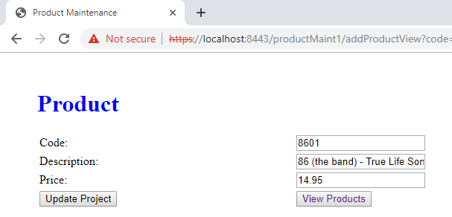

1. Delete Product - After Clicking “Delete”, it will display delete confirmation page where you can choose to delete particular product from the database or go to display products page.

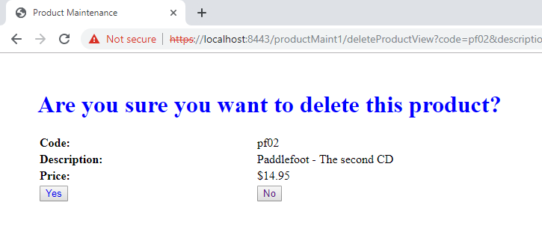

# Project Structure

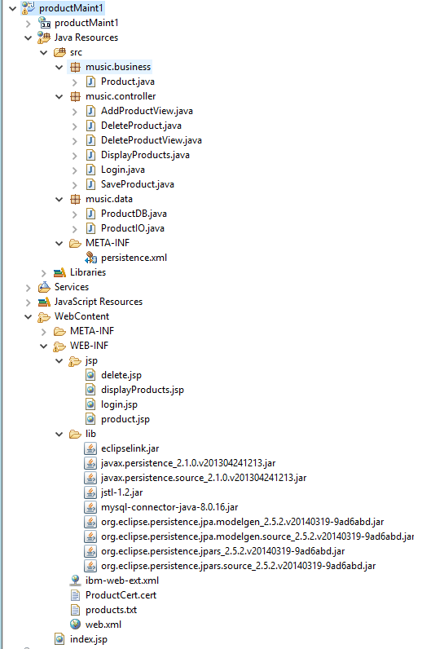

# Code

## JSP

1. **Index.jsp**

<%@ page language=*"java"* contentType=*"text/html; charset=ISO-8859-1"*

pageEncoding=*"ISO-8859-1"*%>

<!DOCTYPE html>

<html>

<head>

<meta charset=*"ISO-8859-1"*>

<title>Product Maintenance</title>

<style>

**body**{

margin: *50px*;

}

**h1**{

color: *blue*;

}

</style>

</head>

<body>

<h1>Product Maintenance</h1>

<a href=*"displayProducts"*>View Products</a>

</body>

</html>

1. **login.jsp –**

<%@ page language="java" contentType="text/html; charset=ISO-8859-1"

pageEncoding="ISO-8859-1"%>

<!DOCTYPE html>

<html>

<head>

<meta charset="ISO-8859-1">

<title>Product Maintenance</title>

<style>

body {

margin: 50px;

}

h1 {

color: blue;

}

a {

text-decoration: none

}

sup {

color: blue;

}

</style>

</head>

<body>

<h1>Login</h1>

<p>Please enter a username and password to continue.</p>

<form action="login">

<table>

<tr>

<td>Username:</td>

<td><input type="text" id="username" name="username"

required="required" /></td>

</tr>

<tr>

<td>Password:</td>

<td><input type="password" id="password" name="password"

required="required" /></td>

</tr>

<tr>

<td colspan="2"><input type="submit" value="Login"></td>

</tr>

</table>

</form>

</body>

</html>

1. **product.jsp**

<%@ page language="java" contentType="text/html; charset=ISO-8859-1"

pageEncoding="ISO-8859-1"%>

<!DOCTYPE html>

<html>

<head>

<meta charset="ISO-8859-1">

<title>Product Maintenance</title>

<style>

body{

margin: 50px;

}

h1{

color: blue;

}

a{

text-decoration: none

}

</style>

</head>

<body>

<h1>Product</h1>

<form action="saveProduct">

<table style="width: 50%; collapse; background-color: white">

<tr>

<td><label for="code">Code: </label></td>

<td><input type="text" name="code" id="code" value = "${product.code}"/></td>

</tr>

<tr>

<td><label for="description">Description: </label></td>

<td><input type="text" name="description" id="description" value = "${product.description}" /></td>

</tr>

<tr>

<td><label for="price">Price: </label></td>

<td><input type="text" name="price" id="price" value = "${product.price}"/></td>

</tr>

<tr>

<td><input type="submit" value="Update Project" /></td>

<td><button type="button">

<a href="displayProducts">View Products</a>

</button></td>

</tr>

</table>

</form>

</body>

</html>

1. **displayProducts.jsp**

<%@ page language="java" contentType="text/html; charset=ISO-8859-1"

pageEncoding="ISO-8859-1"%>

<%@ taglib uri="http://java.sun.com/jsp/jstl/core" prefix="c"%>

<!DOCTYPE html>

<html>

<head>

<meta charset="ISO-8859-1">

<title>Product Maintenance</title>

<style>

body{

margin: 50px;

}

h1{

color: blue;

}

</style>

</head>

<body>

<h1>Products</h1>

<div class="table">

<table style="width: 50%; collapse; background-color: white">

<tr>

<th>Code</th>

<th>Description</th>

<th>Price</th>

<th></th>

<th></th>

</tr>

<c:forEach items="${productList}" var="product">

<tr>

<td height='9px'>${product.code}</td>

<td>${product.description}</td>

<td>$${product.price}</td>

<td><a href="addProductView?code=${product.code}&description=${product.description}&price=${product.price}">Edit</a></td>

<td><a href="deleteProductView?code=${product.code}&description=${product.description}&price=${product.price}">Delete</a></td>

</tr>

</c:forEach>

</table>

<button type="button"><a style="text-decoration: none" href="addProductView">Add Product</a></button>

</div>

</body>

</html>

1. **delete.jsp**

<%@ page language="java" contentType="text/html; charset=ISO-8859-1"

pageEncoding="ISO-8859-1"%>

<!DOCTYPE html>

<html>

<head>

<meta charset="ISO-8859-1">

<title>Product Maintenance</title>

<style>

body{

margin: 50px;

}

h1{

color: blue;

}

a{

text-decoration: none

}

</style>

</head>

<body>

<h1>Are you sure you want to delete this product?</h1>

<table style="width: 50%; collapse; background-color: white">

<tr>

<td><b>Code: </b></td>

<td>${product.code}</td>

</tr>

<tr>

<td><b>Description: </b></td>

<td>${product.description}</td>

</tr>

<tr>

<td><b>Price: </b></td>

<td>$${product.price}</td>

</tr>

<tr>

<td><button>

<a href="deleteProduct?code=${product.code}&description=${product.description}&price=${product.price}">Yes</a>

</button></td>

<td><button>

<a href="displayProducts">No</a>

</button></td>

</tr>

</table>

</body>

</html>

## Servlets

1. **Product.java**

package music.business;

import java.io.Serializable;

import java.text.NumberFormat;

import javax.persistence.Entity;

import javax.persistence.Id;

@Entity

public class Product implements Serializable {

/**

*

*/

private static final long serialVersionUID = 1L;

private Long productId;

@Id

private String code;

private String description;

private double price;

public Product() {

}

public Long getId() {

return productId;

}

public void setId(Long productId) {

this.productId = productId;

}

public void setCode(String code) {

this.code = code;

}

public String getCode() {

return code;

}

public void setDescription(String description) {

this.description = description;

}

public String getDescription() {

return description;

}

public String getArtistName() {

String artistName = description.substring(0, description.indexOf(" - "));

return artistName;

}

public String getAlbumName() {

String albumName = description.substring(description.indexOf(" - ") + 3);

return albumName;

}

public void setPrice(double price) {

this.price = price;

}

public double getPrice() {

return price;

}

public String getPriceCurrencyFormat() {

NumberFormat currency = NumberFormat.getCurrencyInstance();

return currency.format(price);

}

public String getImageURL() {

String imageURL = "/musicStore/images/" + code + "_cover.jpg";

return imageURL;

}

public String getProductType() {

return "Audio CD";

}

}

1. **ProductDB.java**

package music.data;

import java.util.ArrayList;

import java.util.List;

import javax.persistence.EntityManager;

import javax.persistence.EntityManagerFactory;

import javax.persistence.Persistence;

import javax.persistence.Query;

import music.business.Product;

public class ProductDB {

private static List<Product> products = null;

private static final String classNAME = "product";

private static EntityManagerFactory entityManagerFactory = Persistence.createEntityManagerFactory(classNAME);

private ProductDB() {

}

@SuppressWarnings("unchecked")

public static List<Product> selectProducts() {

products = new ArrayList<Product>();

EntityManager entityManager = entityManagerFactory.createEntityManager();

try {

Query query = entityManager.createQuery("select p from Product p");

products = query.getResultList();

entityManager.close();

} catch (Exception e) {

// TODO Auto-generated catch block

e.printStackTrace();

}

return products;

}

public static Product selectProduct(String productCode) {

products = selectProducts();

for (Product p : products) {

if (productCode != null && productCode.equalsIgnoreCase(p.getCode())) {

return p;

}

}

return null;

}

public static boolean exists(String productCode) {

if (productCode != null) {

EntityManager entityManager = entityManagerFactory.createEntityManager();

entityManager.getTransaction().begin();

Product p = entityManager.find(Product.class, productCode);

entityManager.getTransaction().commit();

if (p != null && productCode.equalsIgnoreCase(p.getCode())) {

return true;

} else

return false;

}

return false;

}

public static void insertProduct(Product product) {

try {

EntityManager entityManager = entityManagerFactory.createEntityManager();

entityManager.getTransaction().begin();

entityManager.persist(product);

entityManager.getTransaction().commit();

entityManager.close();

} catch (Exception e) {

// TODO Auto-generated catch block

e.printStackTrace();

}

}

public static void updateProduct(Product product) {

try {

EntityManager entityManager = entityManagerFactory.createEntityManager();

entityManager.getTransaction().begin();

Product p = entityManager.find(Product.class, product.getCode());

p.setDescription(product.getDescription());

p.setPrice(product.getPrice());

entityManager.getTransaction().commit();

entityManager.close();

} catch (Exception e) {

// TODO Auto-generated catch block

e.printStackTrace();

}

}

public static void deleteProduct(Product product) {

try {

EntityManager entityManager = entityManagerFactory.createEntityManager();

entityManager.getTransaction().begin();

Product p = entityManager.find(Product.class, product.getCode());

entityManager.remove(p);

entityManager.getTransaction().commit();

entityManager.close();

} catch (Exception e) {

// TODO Auto-generated catch block

e.printStackTrace();

}

}

}

1. **SaveProduct.java**

package music.controller;

import java.io.IOException;

import java.util.List;

import javax.servlet.RequestDispatcher;

import javax.servlet.ServletException;

import javax.servlet.annotation.WebServlet;

import javax.servlet.http.HttpServlet;

import javax.servlet.http.HttpServletRequest;

import javax.servlet.http.HttpServletResponse;

import music.business.Product;

import music.data.ProductDB;

/**

* Servlet implementation class SaveProduct

*/

@WebServlet("/saveProduct")

public class SaveProduct extends HttpServlet {

private static final long serialVersionUID = 1L;

/**

* @see HttpServlet#HttpServlet()

*/

public SaveProduct() {

super();

// TODO Auto-generated constructor stub

}

/**

* @see HttpServlet#doGet(HttpServletRequest request, HttpServletResponse response)

*/

protected void doGet(HttpServletRequest request, HttpServletResponse response) throws ServletException, IOException {

// TODO Auto-generated method stub

String code = (String) request.getParameter("code");

String description = (String) request.getParameter("description");

String price = (String) request.getParameter("price");

Product p = new Product();

p.setCode(code);

p.setDescription(description);

p.setPrice(Double.valueOf(price));

//Saving new product

if(ProductDB.exists(code))

ProductDB.updateProduct(p);

else

ProductDB.insertProduct(p);

//Displaying products

List<Product> productList = ProductDB.selectProducts();

request.setAttribute("productList", productList);

RequestDispatcher rd = request.getRequestDispatcher("/WEB-INF/jsp/displayProducts.jsp");

rd.forward(request, response);

}

/**

* @see HttpServlet#doPost(HttpServletRequest request, HttpServletResponse response)

*/

protected void doPost(HttpServletRequest request, HttpServletResponse response) throws ServletException, IOException {

// TODO Auto-generated method stub

doGet(request, response);

}

}

1. **Login.java**

package music.controller;

import java.io.IOException;

import javax.servlet.RequestDispatcher;

import javax.servlet.ServletException;

import javax.servlet.annotation.WebServlet;

import javax.servlet.http.HttpServlet;

import javax.servlet.http.HttpServletRequest;

import javax.servlet.http.HttpServletResponse;

/**

* Servlet implementation class Login

*/

@WebServlet(urlPatterns = {"/login"})

public class Login extends HttpServlet {

private static final long serialVersionUID = 1L;

/**

* @see HttpServlet#HttpServlet()

*/

public Login() {

super();

// TODO Auto-generated constructor stub

}

/**

* @see HttpServlet#doGet(HttpServletRequest request, HttpServletResponse response)

*/

protected void doGet(HttpServletRequest request, HttpServletResponse response) throws ServletException, IOException {

// TODO Auto-generated method stub

String username = request.getParameter("username");

String password = request.getParameter("password");

boolean loginStatus = false;

//Please Implement DB based Authentication

if(username!=null && username.equals("user") && password !=null && password.equals("pass"))

{

loginStatus = true;

request.setAttribute("loginStatus", loginStatus);

RequestDispatcher rd = request.getRequestDispatcher("displayProducts");

rd.forward(request, response);

}

else

{

loginStatus = false;

request.setAttribute("loginStatus", loginStatus);

RequestDispatcher rd = request.getRequestDispatcher("/WEB-INF/jsp/login.jsp");

rd.forward(request, response);

}

}

/**

* @see HttpServlet#doPost(HttpServletRequest request, HttpServletResponse response)

*/

protected void doPost(HttpServletRequest request, HttpServletResponse response) throws ServletException, IOException {

// TODO Auto-generated method stub

doGet(request, response);

}

}

1. **DisplayProducts.java**

package music.controller;

import java.io.IOException;

import java.util.List;

import javax.servlet.RequestDispatcher;

import javax.servlet.ServletException;

import javax.servlet.annotation.WebServlet;

import javax.servlet.http.HttpServlet;

import javax.servlet.http.HttpServletRequest;

import javax.servlet.http.HttpServletResponse;

import music.business.Product;

import music.data.ProductDB;

/**

* Servlet implementation class DisplayProducts

*/

@WebServlet("/displayProducts")

public class DisplayProducts extends HttpServlet {

private static final long serialVersionUID = 1L;

/**

* @see HttpServlet#HttpServlet()

*/

public DisplayProducts() {

super();

// TODO Auto-generated constructor stub

}

/**

* @see HttpServlet#doGet(HttpServletRequest request, HttpServletResponse

* response)

*/

protected void doGet(HttpServletRequest request, HttpServletResponse response)

throws ServletException, IOException {

// TODO Auto-generated method stub

/*String filePath = request.getServletContext().getRealPath("/WEB-INF/products.txt");

ProductIO.init(filePath);*/

List<Product> productList = ProductDB.selectProducts();

request.setAttribute("productList", productList);

RequestDispatcher rd = request.getRequestDispatcher("/WEB-INF/jsp/displayProducts.jsp");

rd.forward(request, response);

}

/**

* @see HttpServlet#doPost(HttpServletRequest request, HttpServletResponse

* response)

*/

protected void doPost(HttpServletRequest request, HttpServletResponse response)

throws ServletException, IOException {

// TODO Auto-generated method stub

doGet(request, response);

}

}

1. **DeleteProductView.java**

package music.controller;

import java.io.IOException;

import javax.servlet.RequestDispatcher;

import javax.servlet.ServletException;

import javax.servlet.annotation.WebServlet;

import javax.servlet.http.HttpServlet;

import javax.servlet.http.HttpServletRequest;

import javax.servlet.http.HttpServletResponse;

import music.business.Product;

/**

* Servlet implementation class DeleteProductView

*/

@WebServlet("/deleteProductView")

public class DeleteProductView extends HttpServlet {

private static final long serialVersionUID = 1L;

/**

* @see HttpServlet#HttpServlet()

*/

public DeleteProductView() {

super();

// TODO Auto-generated constructor stub

}

/**

* @see HttpServlet#doGet(HttpServletRequest request, HttpServletResponse response)

*/

protected void doGet(HttpServletRequest request, HttpServletResponse response) throws ServletException, IOException {

// TODO Auto-generated method stub

String code = (String) request.getParameter("code");

String description = (String) request.getParameter("description");

String price = (String) request.getParameter("price");

Product p = new Product();

p.setCode(code);

p.setDescription(description);

p.setPrice(Double.valueOf(price));

request.setAttribute("product", p);

RequestDispatcher rd = request.getRequestDispatcher("/WEB-INF/jsp/delete.jsp");

rd.forward(request, response);

}

/**

* @see HttpServlet#doPost(HttpServletRequest request, HttpServletResponse response)

*/

protected void doPost(HttpServletRequest request, HttpServletResponse response) throws ServletException, IOException {

// TODO Auto-generated method stub

doGet(request, response);

}

}

1. **DeleteProduct.java**

package music.controller;

import java.io.IOException;

import java.util.List;

import javax.servlet.RequestDispatcher;

import javax.servlet.ServletException;

import javax.servlet.annotation.WebServlet;

import javax.servlet.http.HttpServlet;

import javax.servlet.http.HttpServletRequest;

import javax.servlet.http.HttpServletResponse;

import music.business.Product;

import music.data.ProductDB;

/**

* Servlet implementation class DeleteProduct

*/

@WebServlet("/deleteProduct")

public class DeleteProduct extends HttpServlet {

private static final long serialVersionUID = 1L;

/**

* @see HttpServlet#HttpServlet()

*/

public DeleteProduct() {

super();

// TODO Auto-generated constructor stub

}

/**

* @see HttpServlet#doGet(HttpServletRequest request, HttpServletResponse response)

*/

protected void doGet(HttpServletRequest request, HttpServletResponse response) throws ServletException, IOException {

// TODO Auto-generated method stub

String code = (String) request.getParameter("code");

String description = (String) request.getParameter("description");

String price = (String) request.getParameter("price");

Product p = new Product();

p.setCode(code);

p.setDescription(description);

p.setPrice(Double.valueOf(price));

if(ProductDB.exists(code))

ProductDB.deleteProduct(p);

//Displaying products

List<Product> productList = ProductDB.selectProducts();

request.setAttribute("productList", productList);

RequestDispatcher rd = request.getRequestDispatcher("/WEB-INF/jsp/displayProducts.jsp");

rd.forward(request, response);

}

/**

* @see HttpServlet#doPost(HttpServletRequest request, HttpServletResponse response)

*/

protected void doPost(HttpServletRequest request, HttpServletResponse response) throws ServletException, IOException {

// TODO Auto-generated method stub

doGet(request, response);

}

}

1. **AddProductView.java**

package music.controller;

import java.io.IOException;

import javax.servlet.RequestDispatcher;

import javax.servlet.ServletException;

import javax.servlet.annotation.WebServlet;

import javax.servlet.http.HttpServlet;

import javax.servlet.http.HttpServletRequest;

import javax.servlet.http.HttpServletResponse;

import music.business.Product;

/**

* Servlet implementation class AddProductView

*/

@WebServlet("/addProductView")

public class AddProductView extends HttpServlet {

private static final long serialVersionUID = 1L;

/**

* @see HttpServlet#HttpServlet()

*/

public AddProductView() {

super();

// TODO Auto-generated constructor stub

}

/**

* @see HttpServlet#doGet(HttpServletRequest request, HttpServletResponse response)

*/

protected void doGet(HttpServletRequest request, HttpServletResponse response) throws ServletException, IOException {

// TODO Auto-generated method stub

String code = (String) request.getParameter("code");

String description = (String) request.getParameter("description");

String price = (String) request.getParameter("price");

Product p = new Product();

if(code == null)

p.setCode("");

else

p.setCode(code);

if(description == null)

p.setDescription("");

else

p.setDescription(description);

if(price == null)

p.setPrice(0);

else

p.setPrice(Double.valueOf(price));

request.setAttribute("product", p);

RequestDispatcher rd = request.getRequestDispatcher("/WEB-INF/jsp/product.jsp");

rd.forward(request, response);

}

/**

* @see HttpServlet#doPost(HttpServletRequest request, HttpServletResponse response)

*/

protected void doPost(HttpServletRequest request, HttpServletResponse response) throws ServletException, IOException {

// TODO Auto-generated method stub

doGet(request, response);

}

}

## XMLS

1. **Web.xml**

<?xml version=*"1.0"* encoding=*"UTF-8"*?>

<web-app xmlns:xsi=*"http://www.w3.org/2001/XMLSchema-instance"*

xmlns=*"http://java.sun.com/xml/ns/javaee"*

xsi:schemaLocation=*"http://java.sun.com/xml/ns/javaee http://java.sun.com/xml/ns/javaee/web-app_3_0.xsd"*

id=*"WebApp_ID"* version=*"3.0"*>

<display-name>productMaint1</display-name>

<welcome-file-list>

<welcome-file>index.html</welcome-file>

<welcome-file>index.htm</welcome-file>

<welcome-file>index.jsp</welcome-file>

<welcome-file>default.html</welcome-file>

<welcome-file>default.htm</welcome-file>

<welcome-file>default.jsp</welcome-file>

</welcome-file-list>

<security-constraint>

<web-resource-collection>

<web-resource-name>productMaint1</web-resource-name>

<url-pattern>/*</url-pattern>

</web-resource-collection>

<user-data-constraint>

<transport-guarantee>NONE</transport-guarantee>

</user-data-constraint>

</security-constraint>

</web-app>

1. **Persistence.xml**

<?xml version="1.0" encoding="UTF-8"?>

<persistence version="2.1"

xmlns="http://xmlns.jcp.org/xml/ns/persistence" xmlns:xsi="http://www.w3.org/2001/XMLSchema-instance"

xsi:schemaLocation="http://xmlns.jcp.org/xml/ns/persistence http://xmlns.jcp.org/xml/ns/persistence/persistence_2_1.xsd">

<persistence-unit name="product" transaction-type="RESOURCE_LOCAL">

<provider>org.eclipse.persistence.jpa.PersistenceProvider</provider>

<class>music.business.Product</class>

<properties>

<property name="javax.persistence.jdbc.driver" value="com.mysql.cj.jdbc.Driver" />

<property name="javax.persistence.jdbc.url" value="jdbc:mysql://localhost:3306/mydb" />

<property name="javax.persistence.jdbc.user" value="root" />

<property name="javax.persistence.jdbc.password" value="root" />

<!-- EclipseLink should create the database schema automatically -->

<!-- <property name="eclipselink.ddl-generation" value="create-tables"

/> -->

<property name="eclipselink.ddl-generation.output-mode"

value="database" />

</properties>

</persistence-unit>

</persistence>

Note : Please Paste the below code in your server.xml placed under conf/server.xml in order to enable the SSL Authentication. Change the keystore file directory suitable to you.

<Connector SSLEnabled=*"true"* acceptCount=*"100"* clientAuth=*"false"*

disableUploadTimeout=*"true"* enableLookups=*"false"* maxThreads=*"25"*

port=*"8443"* keystoreFile=*"~localdirectory/productMaint1/WebContent/WEB-INF/ProductCert.cert"* keystorePass=*"password"*

protocol=*"org.apache.coyote.http11.Http11NioProtocol"* scheme=*"https"*

secure=*"true"* sslProtocol=*"TLS"* />